E-PROJECT TITLE

**“Cinemaze”**

**Teacher Name: Sir Ali Baig**

**Student:**

***`Muhammad Zahid`***

**Aptech Computer Education**

**Karachi, Pakistan**

Aptech Computer Education

**Certificate**

This is certified that

Mr.Muhammad Zahid

Have successfully Design and Developed

**CINEMAZE**

Submitted by:

Muhammad Zahid

Authorized Signature: **Sir Ali Baig**

# Acknowledgment

First and foremost, I would like to express my deep gratitude and most heartfelt thanks to almighty ALLAH for his blessings, for lightening up my heart with the torch of knowledge and for giving me the ability to complete this project.

I would like to thank Aptech and the team of E-Project for their generous support and clarifying the doubts regarding e-project. I would like to acknowledge the way of explanation which the team of e-project gave in e-project to make website and I am equally grateful to my teacher (Sir Ali) for giving me a moral support and guiding me in different matters regarding project in all the time about the research and writing of this project.

### ****CineMaze: Problem Statement and Solutions****

CineMaze was designed to address the complexities of traditional movie ticket booking, such as long queues, lack of information on movies and showtimes, and the inconvenience of manual seat selection. By introducing an online platform, CineMaze streamlines the entire process, providing users with a modern, efficient, and user-friendly experience for booking tickets and managing profiles, while also giving administrators the tools to manage movies, theaters, and bookings effectively.

### ****Problem Statements:****

1. **Long waiting times in ticket queues at theaters.**
2. **Users lack a centralized platform to explore movie trailers, reviews, and showtimes.**
3. **Difficulty in managing theaters, movies, and showtimes for administrators.**
4. **Inconsistent user experience across devices due to lack of responsive design.**
5. **No streamlined process for booking and seat selection.**
6. **Limited or no administrative control over user bookings and user management.**
7. **Lack of secure authentication for both users and admins.**

### ****Solutions:****

1. **Online Booking System**: Allows users to book tickets from anywhere, eliminating the need for long queues.
2. **Centralized Movie Information**: CineMaze provides trailers, reviews, ratings, and showtimes in one place for a seamless user experience.
3. **Admin Panel**: Administrators can easily manage movie listings, theaters, showtimes, and user bookings via a centralized dashboard.
4. **Responsive Design with Tailwind CSS**: Ensures a consistent and optimized user experience across all devices.
5. **Efficient Booking Process**: Users can select showtimes, filter theaters, and choose seats from different categories (Gold, Platinum, Box).
6. **Comprehensive User Management**: Admins can view and manage user activities, bookings, and access levels with ease.
7. **Secure Authentication**: Implemented a robust login system for both users and admins, ensuring data security and account protection.

**Cinemaze: Online Movie Booking System**

**📖 Project Overview**

CineMaze is a web-based movie ticket booking system that simplifies online ticket bookings. Users can explore movies, watch trailers, read reviews, and book seats from various classes. The system includes both an **Admin Panel** and **User Interface** with secure authentication for both roles.

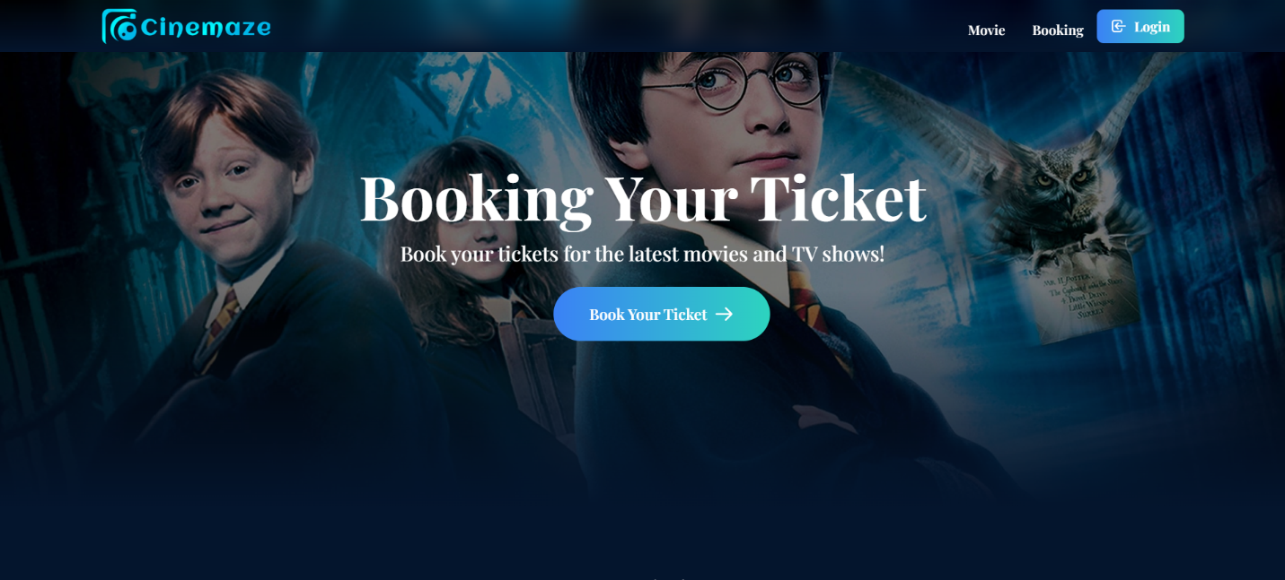

**💻 Technologies Used**

* **Laravel 11**: Powers the backend with routes, controllers, and database interactions, handling user authentication and booking logic.
* **Tailwind CSS**: Builds responsive, modern interfaces for seamless user and admin experiences.
* **MySQL**: Stores critical data such as user profiles, movies, bookings, and admin records.

**👥 Team Members**

1. Muhammad Zahid - Lead Developer
2. Muhamad Sajid
3. Hassam-Ud-Din Khan
4. Syed Abdul Kabeer
5. Shayan Ahmed Chohan
6. Shehryar Affandi

**🚀 Key Features**

* **Admin Panel**: Manage users, movies, and bookings.
* **User Dashboard**: Book tickets, view history, and update profiles.
* **Authentication**: Secure login for both users and admins.
* **Responsive UI**: Tailwind CSS ensures a sleek, adaptive user experience.

**🔐 Authentication System**

* User Registration & Login
* Admin Authentication

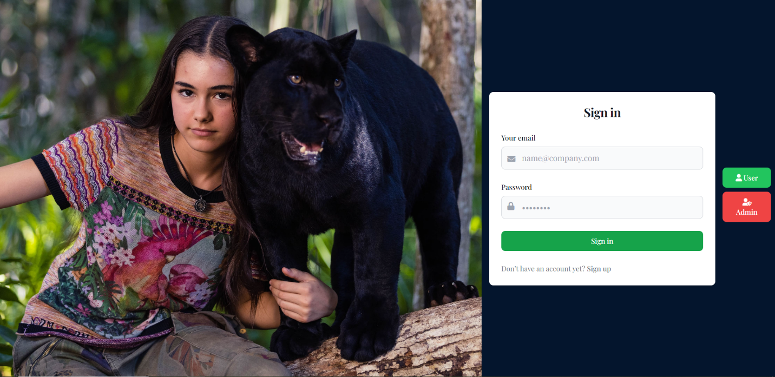

**🛠️ Admin Panel**

* **Movies**: Add, edit, or delete movie listings.
* **Booking**: Manage bookings and available movies.
* **Users**: View and manage registered users.

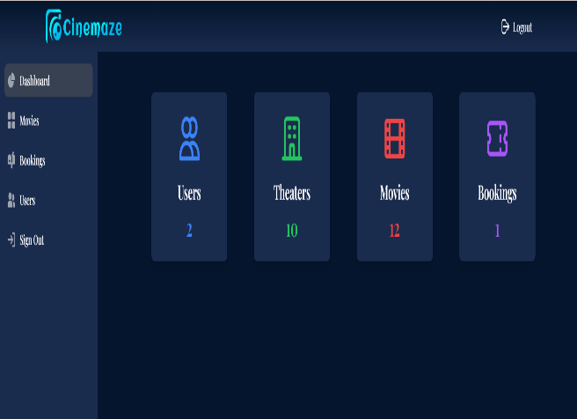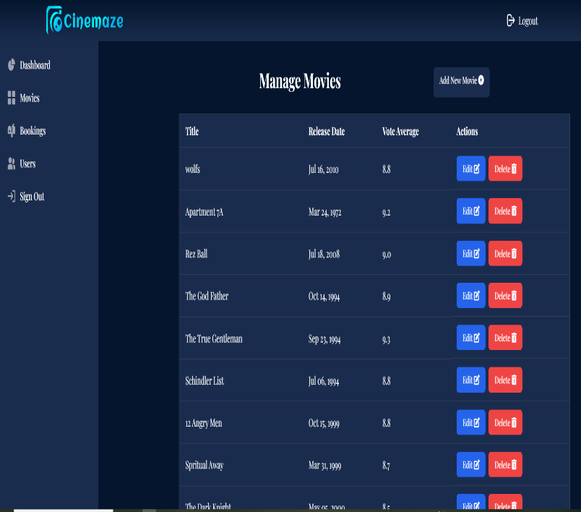

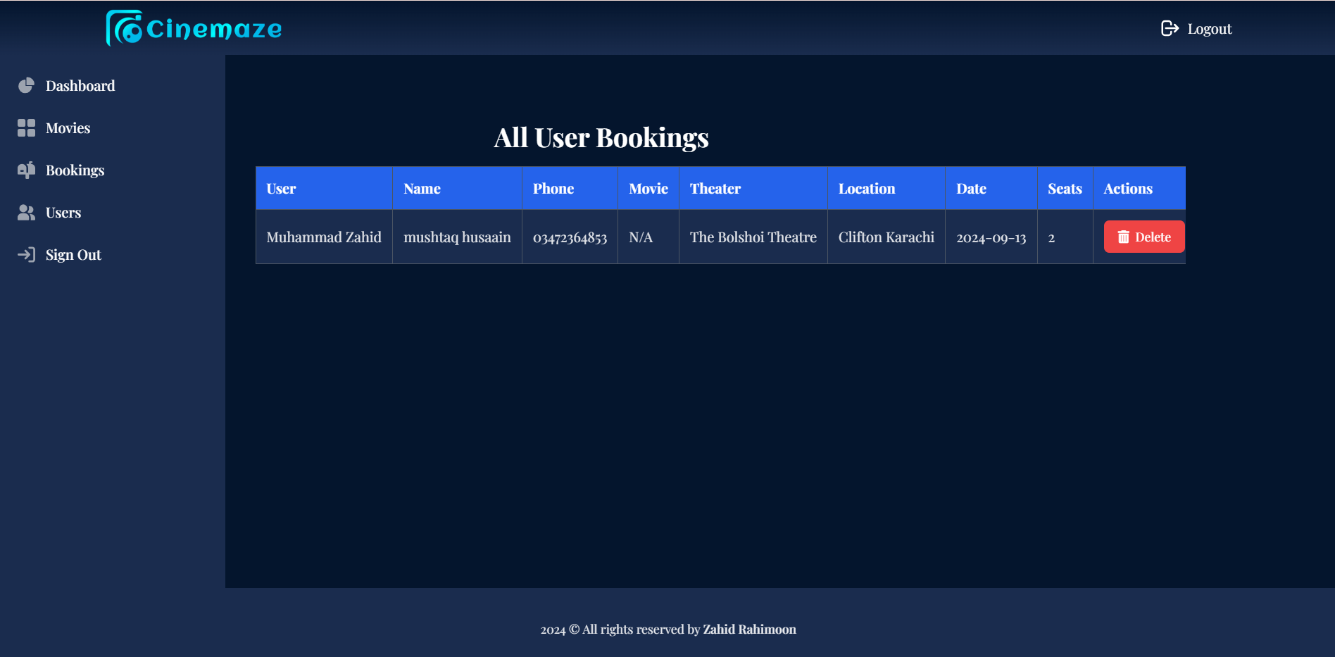

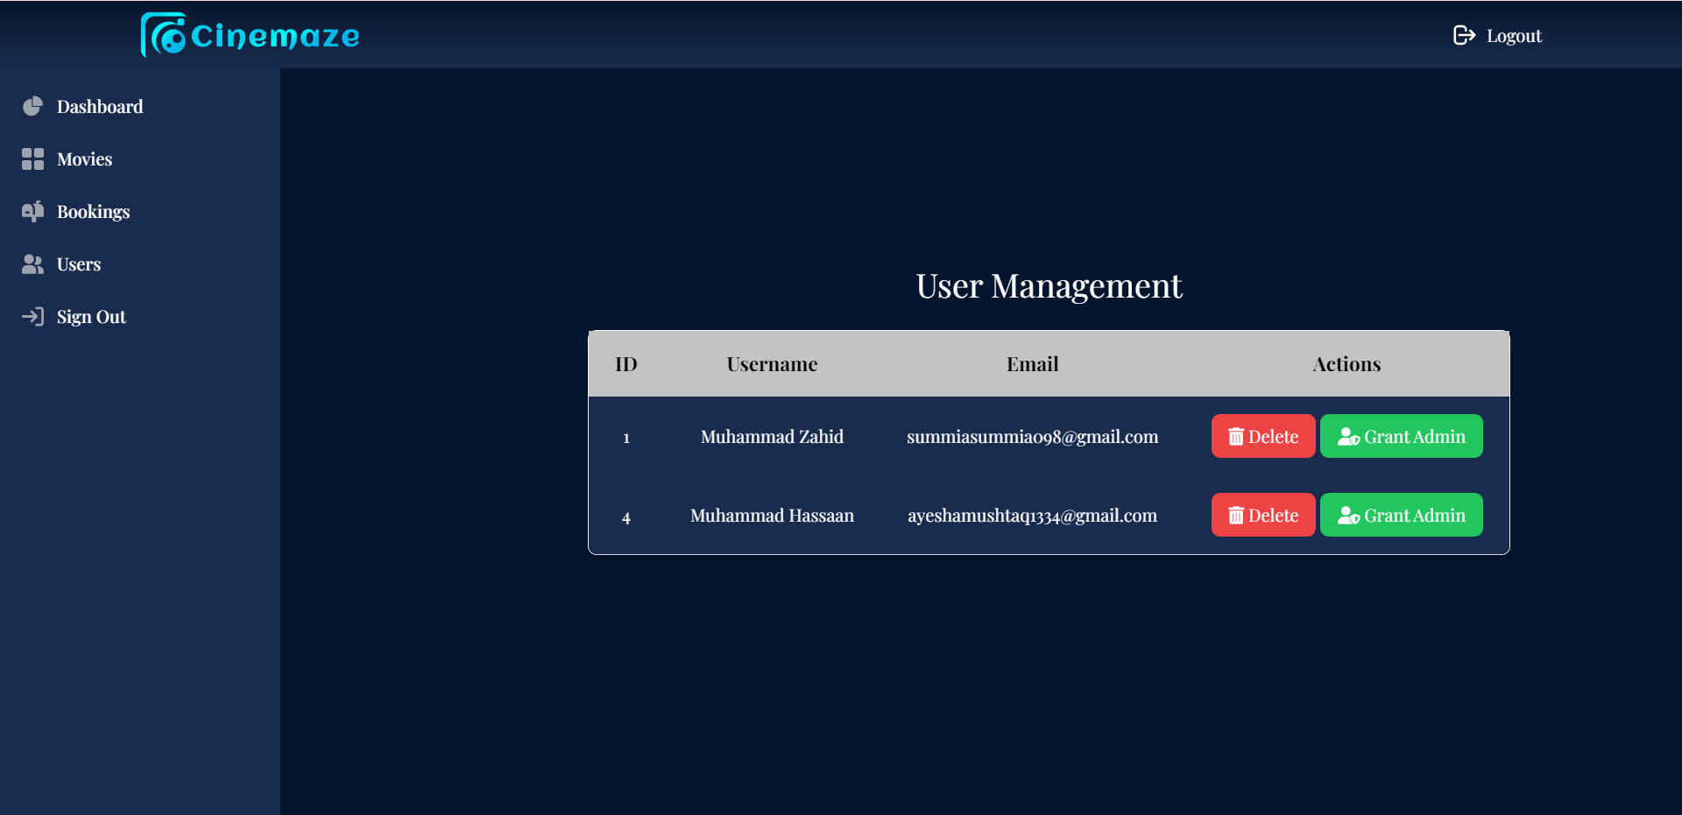

**🎟️ User Interface**

* **Browse Movies**: Explore titles, genres, and trailers.
* **Book Tickets**: Select seats from Gold, Platinum, or Box classes.
* **Filters**: Filter movies by genres, ratings, and showtimes.
* **Profile Management**: Update details and view bookings.

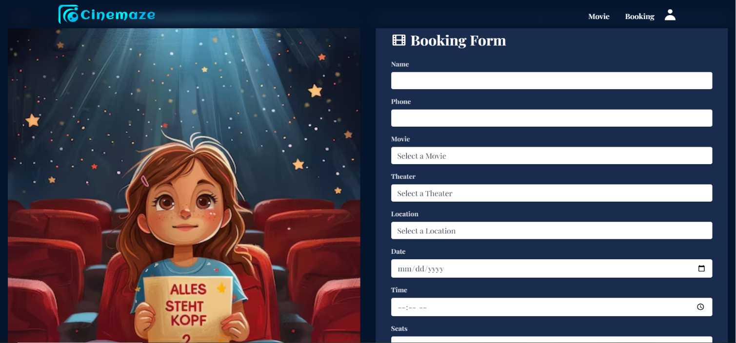

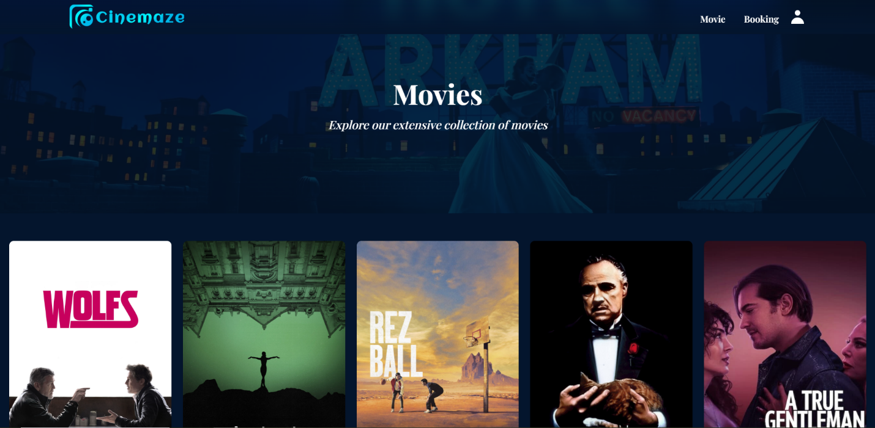

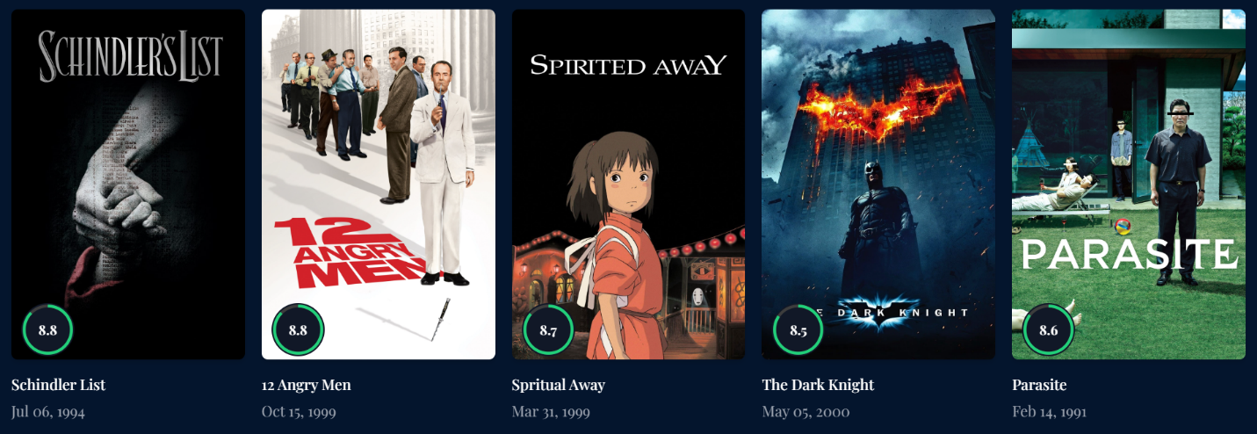

**⭐ Movie Details**

* Detailed movie descriptions and trailers on each movie page.

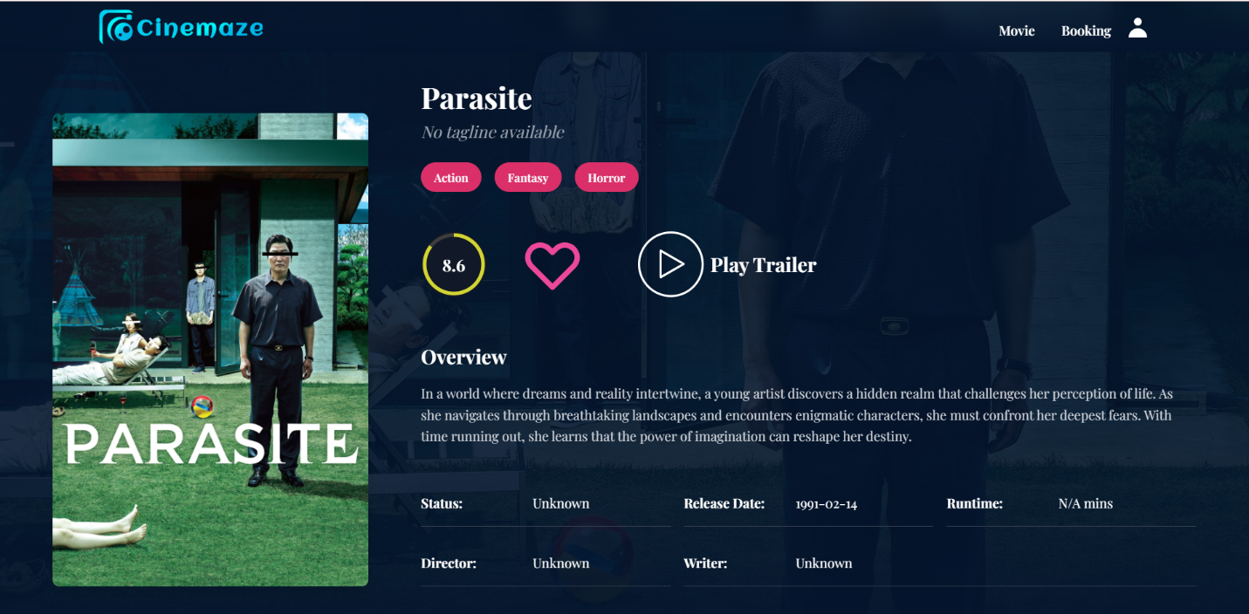

**ER Diagram**

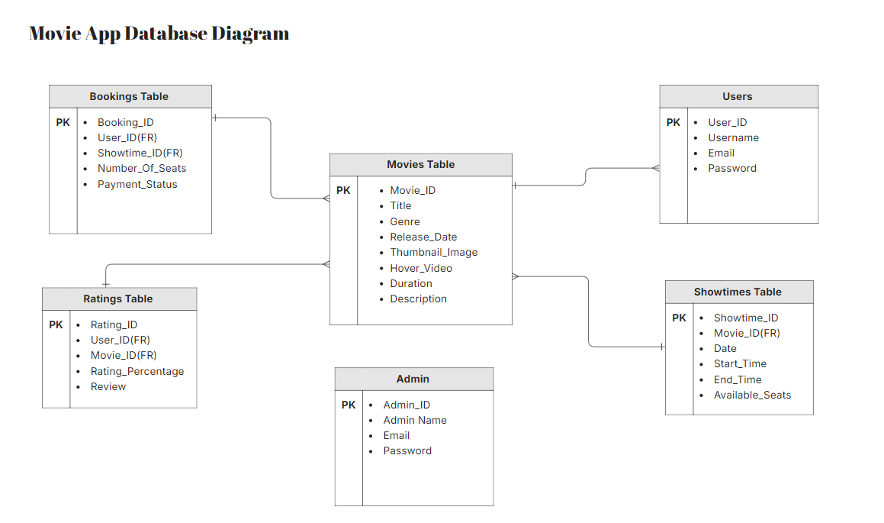

**📊 Conclusion**

CineMaze transforms the movie ticket booking experience, combining powerful admin tools with a user-friendly interface. From browsing showtimes to booking securely, CineMaze covers all essential aspects of online movie ticketing.